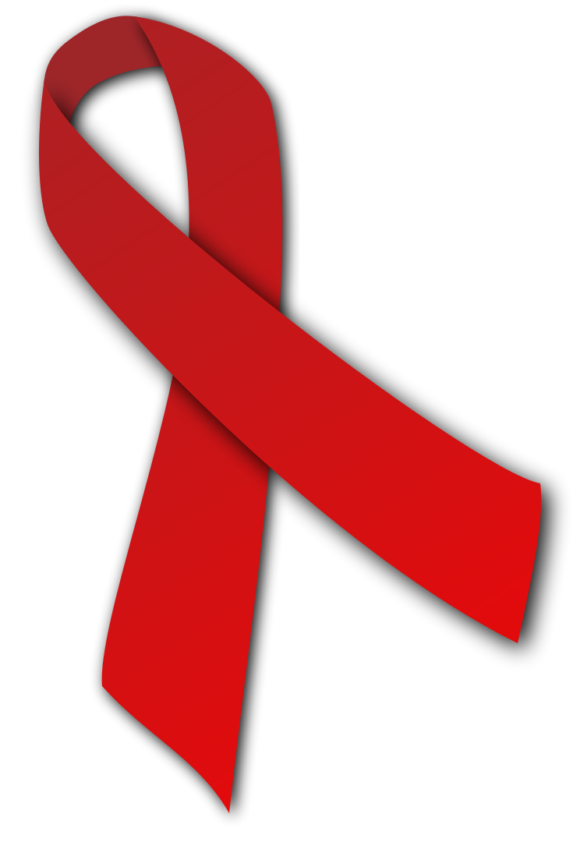
Oak Park School Celebrates Red Ribbon Week 2021
October 25th-27th 2021
Red Ribbon Week is the nation's oldest and largest drug prevention and awareness program in the United States. It is a weeklong campaign to encourage students to pledge to live drug and alcohol free.

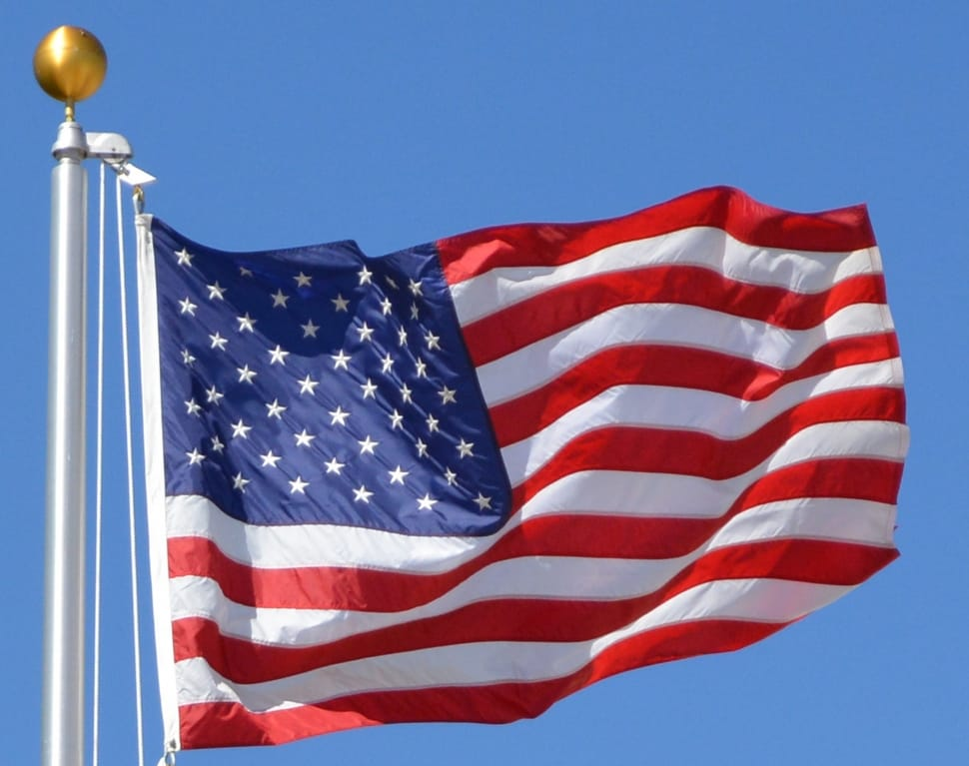
Monday: “Proud to be Drug Free” (Wear red white and blue)

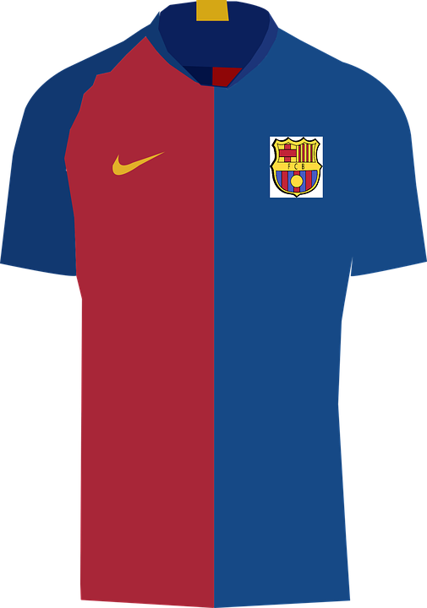
Tuesday: “Team up Against Drugs” (Wear your favorite jersey or shirt)

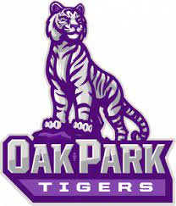
Wednesday: “OP Chooses to be Drug Free” (Wear our school color)

Thursday: No School - Conferences

Friday: No School - Conferences

